**D.A.V. Public School**

**Khera Khurd / Budhpur**

**Holidays Home Work (2017 – 2018)**

**Class – II**

***Dear children,***

***Enjoy yourself during this winter break, have loads of fun. Make the beginning of the year fruitful and enjoyable. Kindly complete the given homework during your winter break.***

**English:**

1. Search any ten past forms from the newspaper and paste it in the activity file.
2. Learn story written in your wards school diary for story narration.

**Math:**

1. Make a smiley face with whole, half and quarter. (in activity file)
2. Revise tables from 2 to 9.

**EVS:**

1. Make a collage land, water & air transport in activity file.
2. Paste pictures of things used in rainy, summer & winter season in activity file.

**Hindi:**

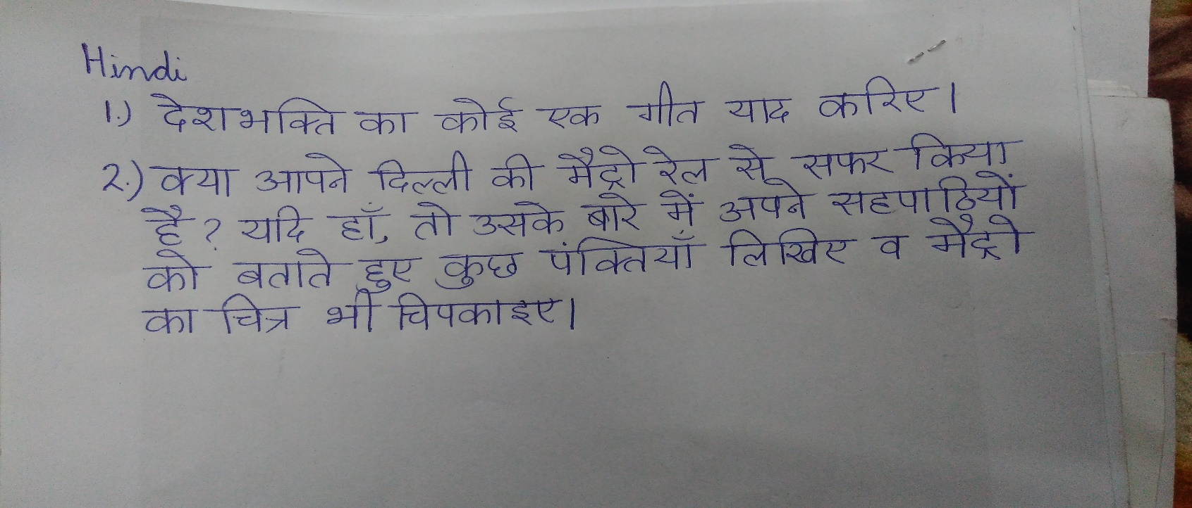

**Art & Craft:**

1. Make any two scenes of your choice on A4 size pastel sheet.