DAV PUBLIC SCHOOL KHERA KHURD / BUDHPUR

School Website : davpskherakhurd.com , School Tel No. 01127844245 , 01127201930

SUMMER BREAK HOLIDAYS HOMEWORK

Class-X

**English**

Home Assignment for Summer Vacation Note :

Note : Do your H.W on White A3 Size Sheet.

1. Roll no 1-10 Write a famous quote of “William Shakespeare”.
2. Roll No 11 -20 : Prepare a poster on “Save environment” or 5 idioms with their meanings ..
3. Roll No 21-28 – Prepare a book mark with a proverb written on it
4. Learning work – Learn and revise the syllabus of periodic test to be held in July after the vacation

**Hindi**

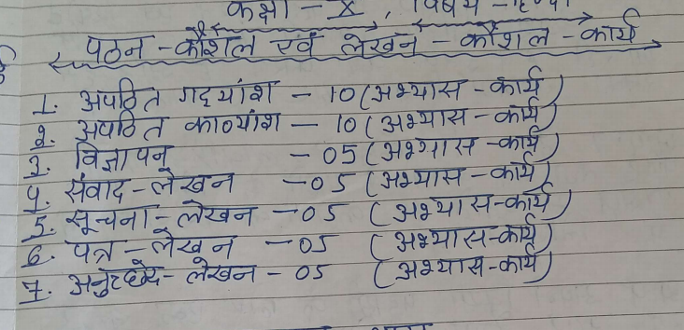

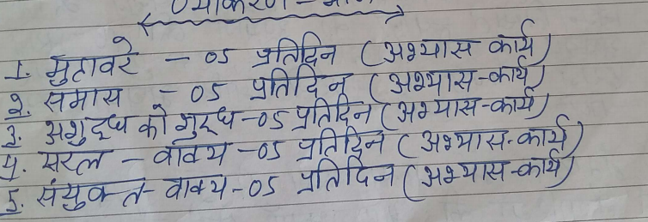

**Maths** : Do all the questions given in NCERT Maths Exampler Book for the chapters taught to you in the class in separate Notebook .

**Science** : Do all the questions given in NCERT Science Exampler Book for the chapters taught to you in the class in separate Notebook .

**S,Science**

1. The project is compulsory for all the students.

2. The holidays homework will be assessed under project work for Social Science.

**Instructions:-**

1. Only A-4 sized sheets to be used.
2. The project will be handwritten. No printouts are acceptable.
3. Pictures/illustrations should be correct, visible and labelled.
4. Credit will be given to originality and creative use of materials.
5. Total number of pages should be 10-15, excluding the cover page, Acknowledgement, Index, Project overview and Bibliography.
6. The pages will be arranged in the following order:-

a) Cover page showing  project title,      Students information, School and year

b) Index/contents with page number

c) Project Overview purpose, aim, methodology and experiences while doing the project

e) Chapters with relevant headings

f) Bibliography (will be the last page) showing the list of references, websites etc. used for making the project

6. The finished project will be spiral bound as a single dossire, before submission to the teacher.

7. The class will be divided in three groups as per their roll no.'s-

R.N.1-10 -> Disaster management

                      Sub topic-

                    1. Maharashtra flood of 2005         Mumbai

                    2. Beas River Tragedy 2014

                    3. Bellandur Lake crisis 2015         Bengaluru

R.N.11-20 -> Popular struggles and movements

R.N.21&above -> Money and credit

**Computer**

Make a model on any one social sites like

1. Facebook
2. Twitter
3. What’s App
4. Instagram

**Music**

Learn

1. Sargam 10,11,12,13
2. What do you understand by Song. How are they important to us .
3. Write in 150 words.

**Art**

1. Make a painting with cotton thread on Khadi cloth as shown in the picture in A 4 Size.

