**English**

Home Assignment for Summer Vacation Note : Do your H.W on White A3 Size Sheet.

Roll no 1-10 Prepare a poster on Digital India

Roll No 11 -20 : Prepare a greeting card for a physically disabled person with a positive message written on it.

Roll No 21-30 – Write a slogan on” Women Empowerment “.

Roll 31-40 – Prepare a book cover of your book Beehive

Roll No 41-48 Prepare a book cover of your book Moments

Larning work – Learn and revise the syllabus periodic test t be held in july after the vacation

Hindi

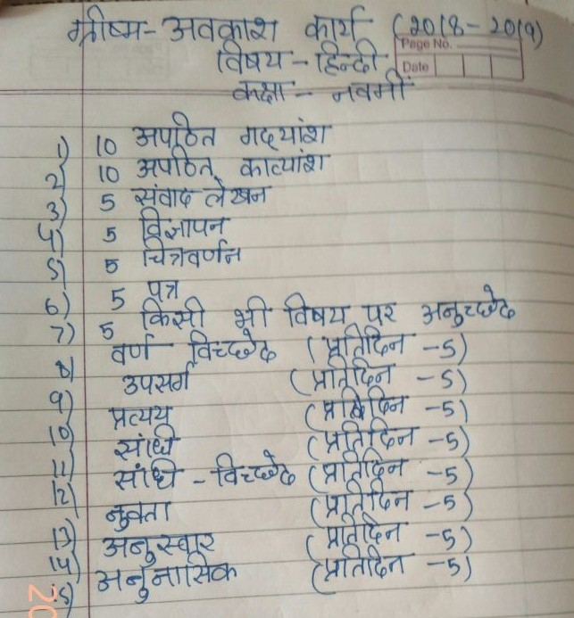

**Maths** : Do all the questions given in NCERT Maths Exampler Book for the chapters taught to you in the class in separate Notebook .

**Science** : Do all the questions given in NCERT Science Exampler Book for the chapters taught to you in the class in separate Notebook .

**S.SC**

Project on disaster management is compulsory for all the students .

**Guidelines for the project**

1. Project to be done in activity file.
2. Project should be hand written 5-10 pages.
3. Newspaper cuttings , maps , diagrams , illustrations are must.
4. Index/ contents with page no. and acknowledgement is also must.

Topic 1- Make a project on Earthquake prone areas in India – causes , impact on life and property , mitigation strategies used to reduce the impact of the earthquake. ( Roll 1-10)

Topic 2 - Project on areas prone to cyclone in India – warning system , effects of cyclones , mitigation strategies to be used while construction of buildings .( Roll 11-20)

Topic 3 – Survival skills during and after disaster ( Roll 21-30)

Topic 4- A brief pocket guide on ‘First Aid. Roll no (31-40)

**Music**

Learn sargam 7,8,9,10

Paste pictures of singer , vocalist and actors in your notebook any five.

**Computer**

1. Make a chart on Cybercrime

**Art**

Decorate a mirror with the help of broken CD , Beads , Pebbles and M- seal . Color it with glass colors as shown in the picture.